**Dockerfile**

* Dockerfile contains instructions that are required to build Docker image.
* In Dockerfile we will use domain specific language (DSL) keywords.
* The default Docker file name is “Dockerfile”. But we can take any file name as Docker file.

**Commonly Used Commands in Docker File**

* FROM
* COPY
* RUN
* CMD
* Etc.

**Note:**

* Dockerfile commands are case in-sensitive.
* The commands placed in Docker file will execute sequential from top to bottom.

**FROM**

* It used to specify base image to run our application.
* The base image can be OS name, language name or application name.
* Syntax:

FROM <image-name>

* Example:

FROM tomcat

FROM Ubuntu

FROM python

FROM mysql

**COPY**

* It is used to copy files/ folder from current machine to Docker image while creating Docker image.
* Syntax:

COPY <source> <destination>

* Example:

COPY . /app

**RUN**

* It is used to execute commands on top of base image.
* Run command instructions will execute while creating an image.
* Example:

RUN mkdir workspace

RUN apt-get install python

**CMD**

* It is used to execute commands on top of base image.
* CMD command instructions will execute while creating container.
* Example:

CMD [“option1”, “option2”]

Etl.py

import streamlit as st

import pandas as pd

data = {

        'Task': ['Extract', 'Transform', 'Load'],

        'Status': ['Completed', 'InProgress', 'Pending']

    }

df = pd.DataFrame(data)

st.write('ETL Pipeline Execution Status', df)

**Dockerfile**

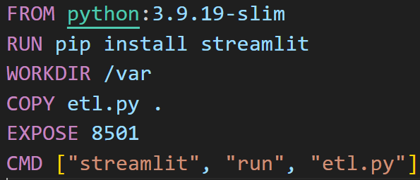

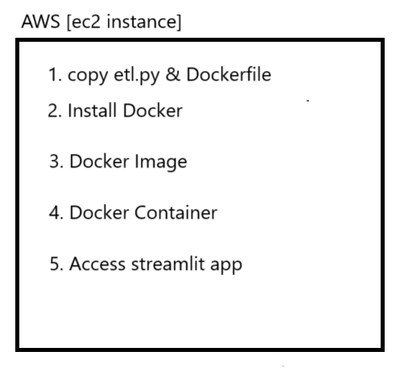

**Creating Docker Image**

docker build -t image_name .

**Display All Docker Images**

docker images

**Create Docker Container**

docker run -d -p external_port:internal_port image_name

-d = running container in detached mode

-p = used for port forwarding

**Display Docker Containers**

docker ps